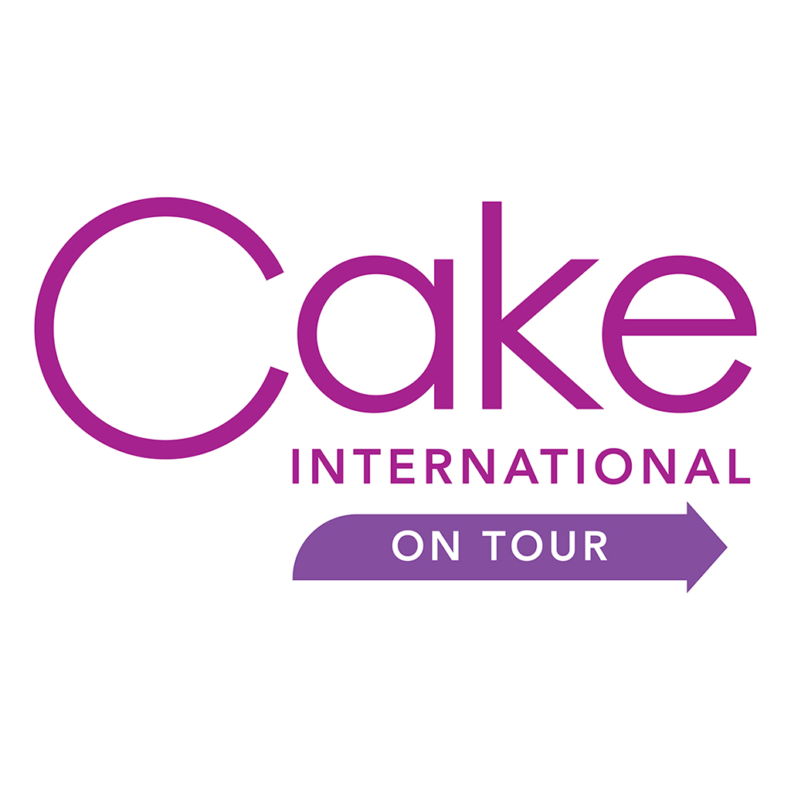 PRESS OPPORTUNITIES
Pre-show Press Opportunities
One Voice Media is looking for significant news and feature stories to sell-in to the national and regional press. They will need this information at least 3 months in advance of the show for national press. For any regional or local stories, information will be needed 6-8 weeks in advance of the show. So, if you have something exciting or interesting please do let the One Voice team know. In order to help maximise your company’s presence at the show, please answer all of the questions below and provide any further relevant content to One Voice Media for inclusion in the Cake International activity. All of the information that you submit will be reviewed by One Voice Media and considered for use in the PR campaign. As with any PR activity, coverage is not guaranteed.
On-site PR Activities
One Voice Media invite all relevant UK consumer and broadcast media to attend and report on the shows.
Tell us your news! Let the One Voice team have a press release or some detailed information about you and your stand. Journalists will ask the One Voice team about any points of interest at the show. If they know about your product launches, exciting displays, on-stand activities or competitions, experts on your stand for comment/interview, they can direct them to your stand.

Post PR Activities

After the event, there’s still a chance to be included in press opportunities. Post show releases and product photography of the event will be sent to the relevant media. To be included, please send information to One Voice Media on the last day of the show to be included with any post show news and reporting.

Please complete:

BUSINESS NAME:
SHOW AND VENUE:
CONTACT NAME:
EMAIL/PHONE NUMBER:
WEBSITE:
FACEBOOK:
TWITTER:
INSTAGRAM:
NO. OF YEARS EXHIBITING AT CI:

TO INCREASE YOUR CHANCES OF BEING PUT FORWARD, PLEASE COMPLETE THE FOLLOWING IN AS MUCH DETAIL AS POSSIBLE.

Please tell us, in 200 words or less, about your business and what you will be exhibiting at the show.
Do you have any interesting stories about your business – for example, what inspired you to start it? How long has it been running?
Please continue on a separate sheet if required
Will you be exhibiting anything special at the show – for example any exciting new / innovative products? Or particular best-sellers?
Product name | About the product
Have you received any awards? Please tell us what the award was, when you received it and who the award was from.
Is there a Celebrity Ambassador or famous face associated with your brand?

PLEASE NOTE: As with any PR activity, coverage is never guaranteed.

Please send high resolution images that you are happy to be used for press purposes via email to the press contacts below. (Max size: 6MB).

PR CONTACTS: If you have any questions, or would like to discuss your plans and the opportunities available, please contact the One Voice PR team on 01392 280303 and speak to Sharon Foxwell or Jo Holdom (Sharon-jo@onevoicemedia.co.uk)

